Task 4p: Login and Registration Page

Header bar:

This header contains the login button and the return logo button

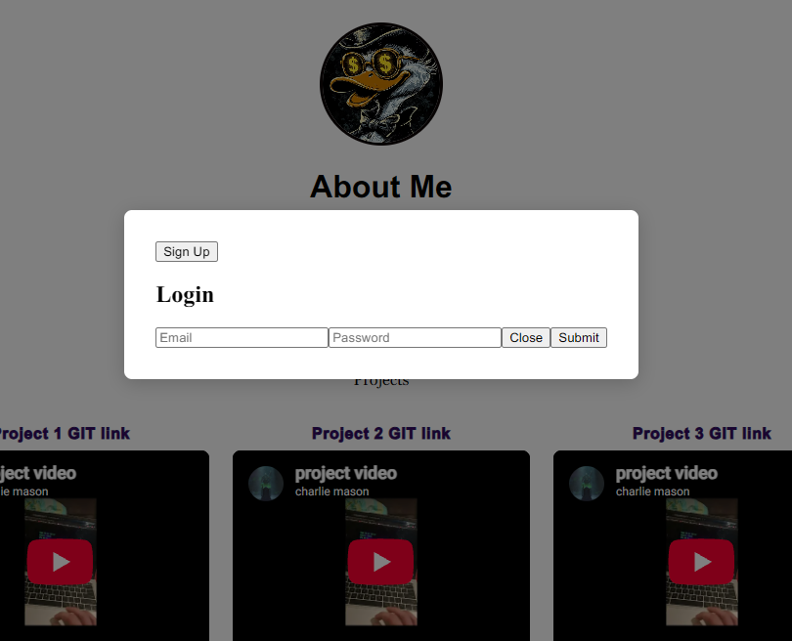
login overlay:

pressing the login button creates this overlay that disables the background and lets you choose to login or create a new account if you don’t have one.

Signup page:
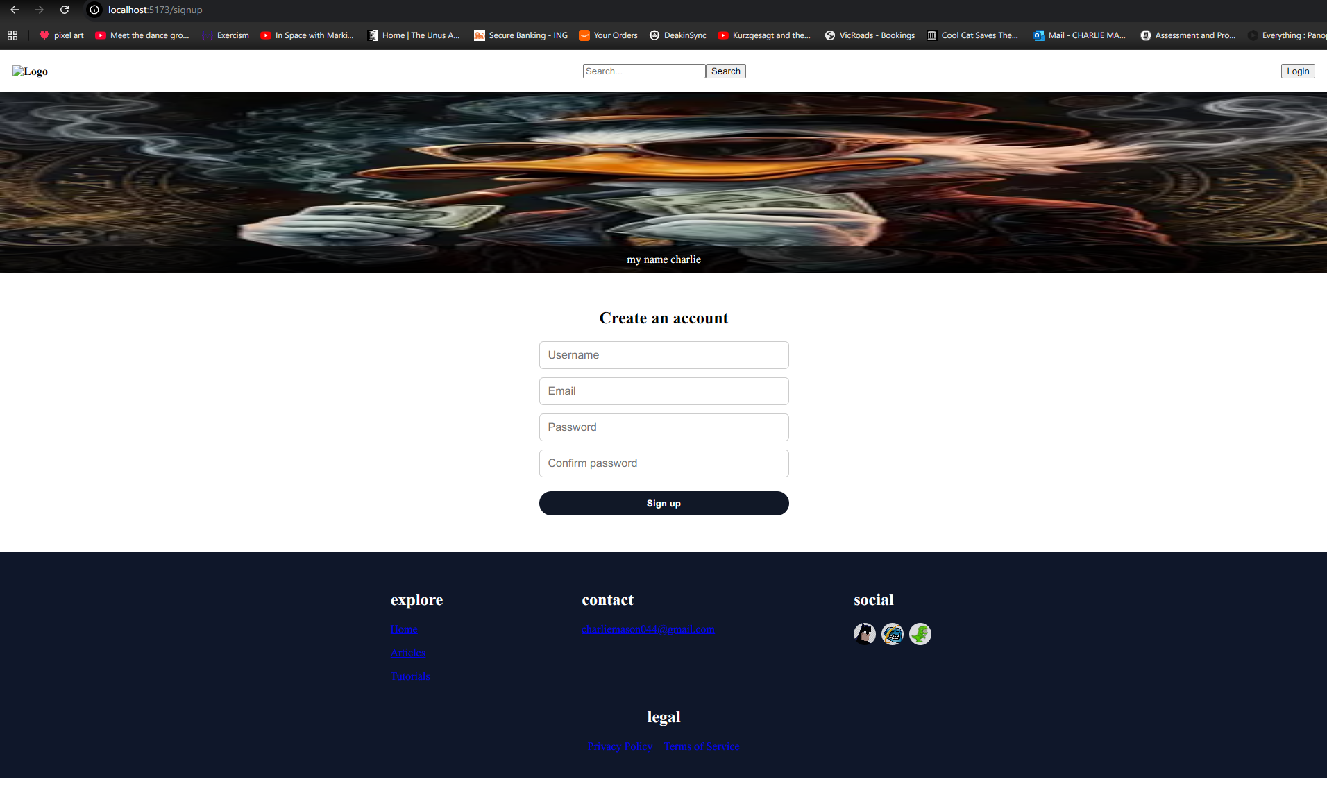
Hitting the signup page redirects you to a new signup page where you can create a new account.

Duplicate accounts:
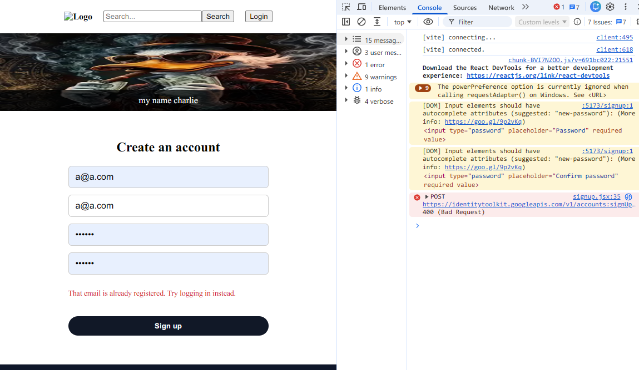
If you attempt to create a new account with an email that already exists then firebase will reject your request and a note will appear to inform the user

Invalid Login states:
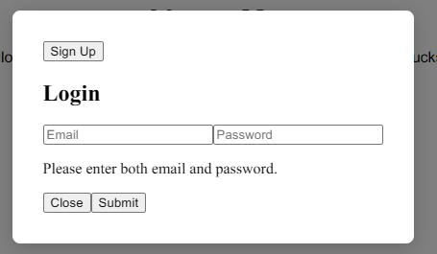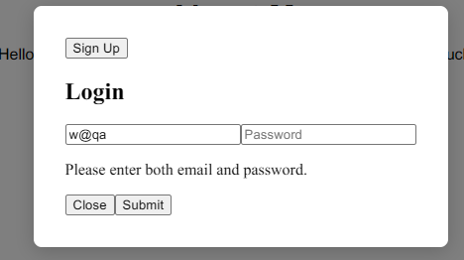
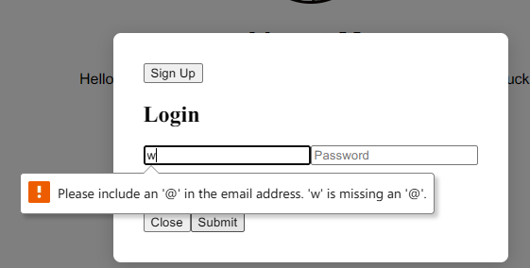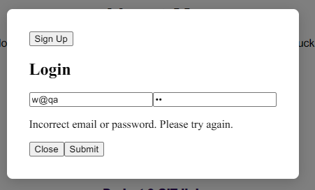
The html box for the email is set to type email to validate email input. The handle submit function validates all the inputs are correct and actually entered.
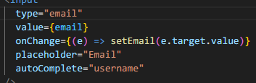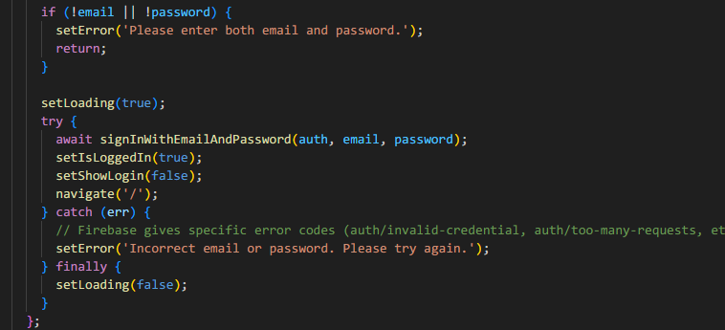

Signup code:
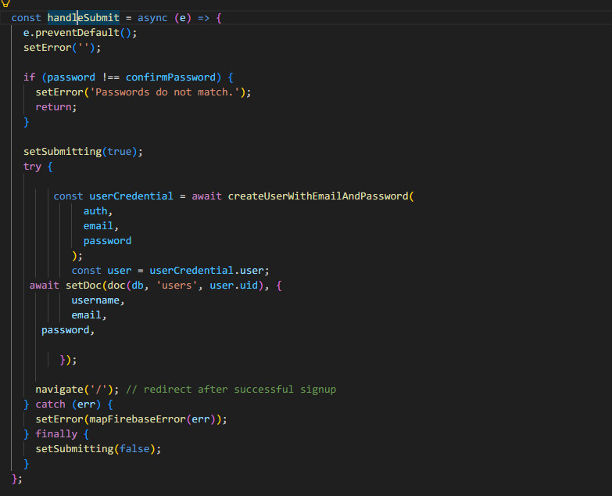
Apon hitting submit the signup.jsx code runs the function that confirms the password validating and then attempts to create a new set of user credentials using the firebase library built in user with email and password features and catches any errors like the duplicate accounts we had earlier.

Firebase:
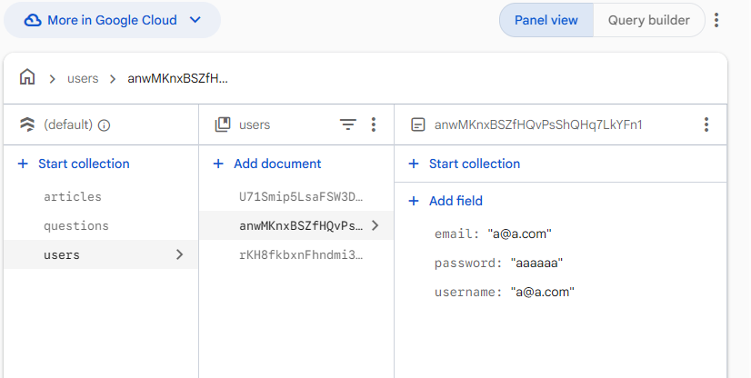
All the accounts are stored in firebase like so.

Login:

Apon successful login the page changes an reveals the post button and remove the login button

Login.jsx:
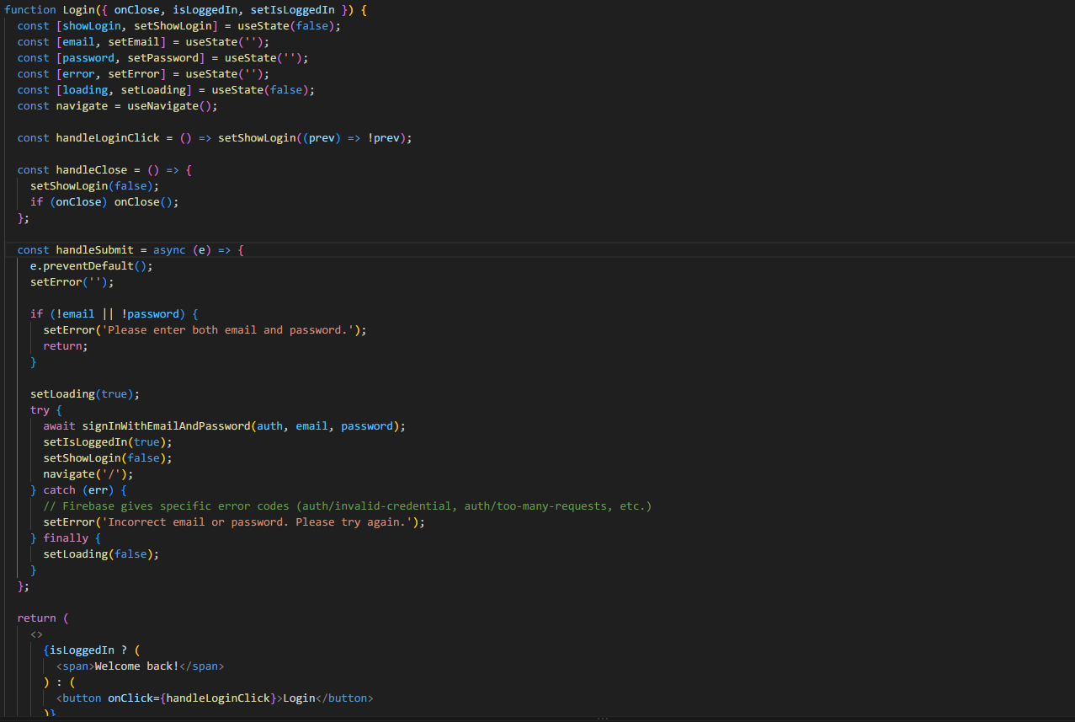
The logged in state controls whether we can see the login or post button and is changed by validating the submitted username and password which is handled by the firebase library.

Page navigation:
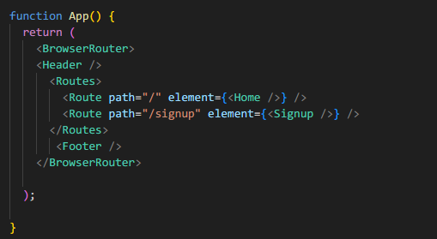
These are the routes that all the buttons can go to wrapped in the header and footer elements.

Video link: https://deakin.au.panopto.com/Panopto/Pages/Viewer.aspx?id=1230ba37-3779-4439-9f0e-b4b4000613e6
GITLAB link: https://gitlab.deakin.edu.au/s223391013/SIT_313_frontend_reimport/-/tree/e846a28dce6f8d15c764980a62f4b96778345664/p4

